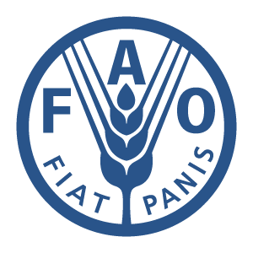

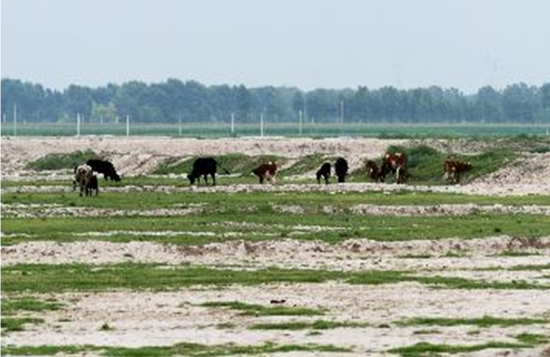

GLOBAL
ENVIRONMENT FACILITY
IN CHINA·JILIN
全球环境基金在中国·吉林（一）

吉林GEF项目办公室
Jilin GEF Project Management Office
2017年3月
March 2017
目 录
一、项目背景 2
1.1全球环境基金（GEF） 2
1.2中国与全球环境基金的合作 2
1.3 联合国粮食及农业组织（FAO） 2
1.4吉林GEF项目 3
二、吉林西部地区基本情况 14
2.1自然情况 14
2.2骨干工程 16
三、项目内容 18
3.1为在农牧用地中采用可持续水土管理模型完善政策、法规和监管框架，包括能力建设 23
3.2在查干湖周边设计并试点实施可持续水土管理和保护性农业 23
3.3恢复湿地和草原，从而改善查干湖周边区域的生物多样性保护机制 24
3.4监测和评估项目活动，推广项目成果，提高公众环保意识 25
四、预期成果和环境效益 26
4.1预期成果 26
4.2环境效益 27

一、项目背景Background

1.1全球环境基金（GEF）Global Environment Facility
GEF是目前政府间环境保护方面最重要的多边机构之一，致力于提高全球环境效益，促进环境领域的国际合作，主要通过以赠款或其它形式为受援国在生物多样性、气候变化、化学品、国际水域、土地退化和臭氧层损耗等领域提供资金支持，鼓励和支持发展中国家开展对全球有益的环境保护活动。
The GEF is one of the most important intergovernmental mechanisms for promoting environmental protection. The GEF is committed to achieving global environmental benefits and promoting international cooperation in environment-related fields. The GEF motivates and support developing countries’ initiatives that benefit the global environment by providing grants in the areas of biodiversity, climate change, persistent organic pollutants, international waters, land degradation and ozone depletion.

1.2中国与全球环境基金的合作China’s participation and contribution
中国是GEF的创始国和受援国，但同时也是捐资国。财政部是GEF在中国的窗口单位，负责GEF在华业务归口管理。吉林西部地区苏打盐碱湿地农牧用地生物多样性保护与可持续土地管理项目为GEF全资项目。
China is a founding member as well as beneficiary and donor of the GEF. As the GEF focal point of China, Ministry of Finance (MOF) is responsible for all GEF related affairs in China. The project” Biodiversity Conservation and Sustainable Land Management in the Soda Saline-alkaline Wetlands and Agro-Pastoral Landscapes in the Western Area of the Jilin Province” with GEF grants is full-size project.

1.3 联合国粮食及农业组织（FAO）Food and Agriculture Organization of the united nations
FAO为吉林西部地区苏打盐碱湿地农牧用地生物多样性保护与可持续土地管理项目的国际执行机构。FAO的工作目标是：为消除饥饿、粮食不安全和营养不良做贡献；以可持续方式增加并改善农业、林业和渔业产品及服务；减少农村贫困；建立包容性更强和效率更高的农业和粮食系统；增强对灾害的抵御能力。工作重点是帮助发展中国家制定农业发展政策和战略以及为发展中国家提供技术援助。
The international executing agency of the project ”Biodiversity Conservation and Sustainable Land Management in the Soda Saline-alkaline Wetlands and Agro-Pastoral Landscapes in the Western Area of the Jilin Province” is the FAO. The job objectives for FAO are: the eradication of hunger, food insecurity and malnutrition; agriculture, forestry, and fisheries products as well as its serves will be increased and improved by a sustainable way; reduced rural poverty; to build a agriculture and food system with stronger containment and higher efficiency; enhanced the livelihood ability to defense the disaster. Key work is helping the developing countries to formulate policies and strategies about agriculture develop, and supply technology support to the developing countries.

1.4吉林GEF项目The Jilin GEF project
2009年9月22日，联合国气候变化峰会在联合国总部举行，国家主席胡锦涛出席峰会开幕式。胡锦涛主席指出：中国高度重视和积极推动以人为本、全面协调可持续的科学发展，明确提出了建设生态文明的重大战略任务，强调要坚持节约资源和保护环境的基本国策，坚持走可持续发展道路，在加快建设资源节约型、环境友好型社会和建设创新型国家的进程中不断为应对气候变化作出贡献。
President Hu Jintao attended the United Nations Climate Changes Summit in the UN Headquarters on September 22,2009. President Hu pointed out that “China attaches great importance to and has actively promoted scientific development, that is, comprehensive, balanced and sustainable development which puts people’s interest first. We have set the building of a conservation culture as a major strategic task. We will adhere to the basic state policy of conserving resources and protecting the environment and follow the path of sustainable development. We will make fresh contributions to tackle climate change as we accelerate transition to a resource-conserving and environment-friendly society and make China a country of innovation.
2009年12月，我省提出该项目申请，2012年2月获GEF芭布总裁签批（项目编号4632），同年6月通过了GEF理事会审议。
The project was applied by our province in Dec., 2009, and gets endorsement from the president Barbut in Feb., 2012 (No. 4632), and passed deliberation of GEF council in June, 2012.
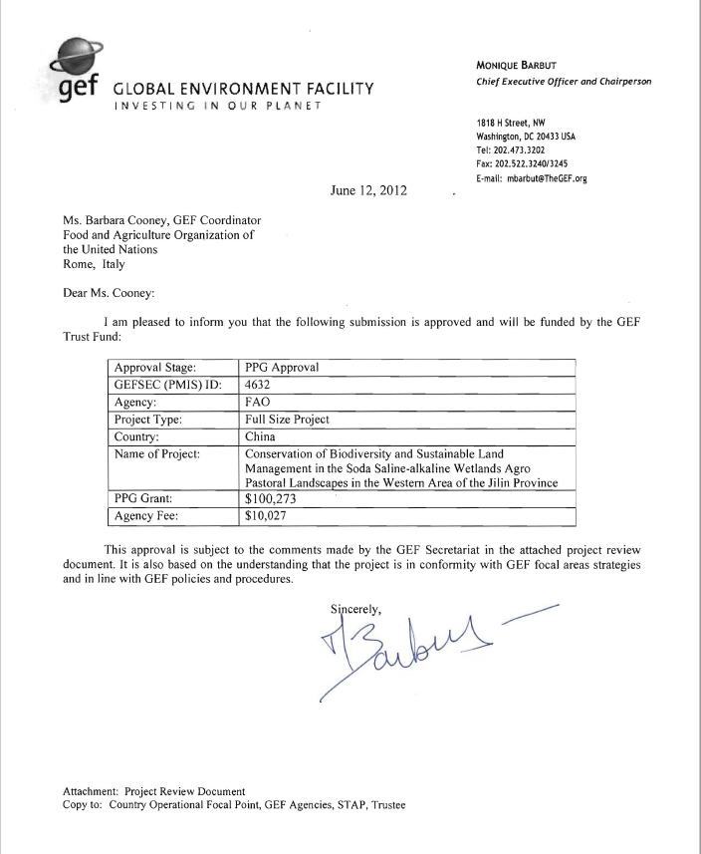
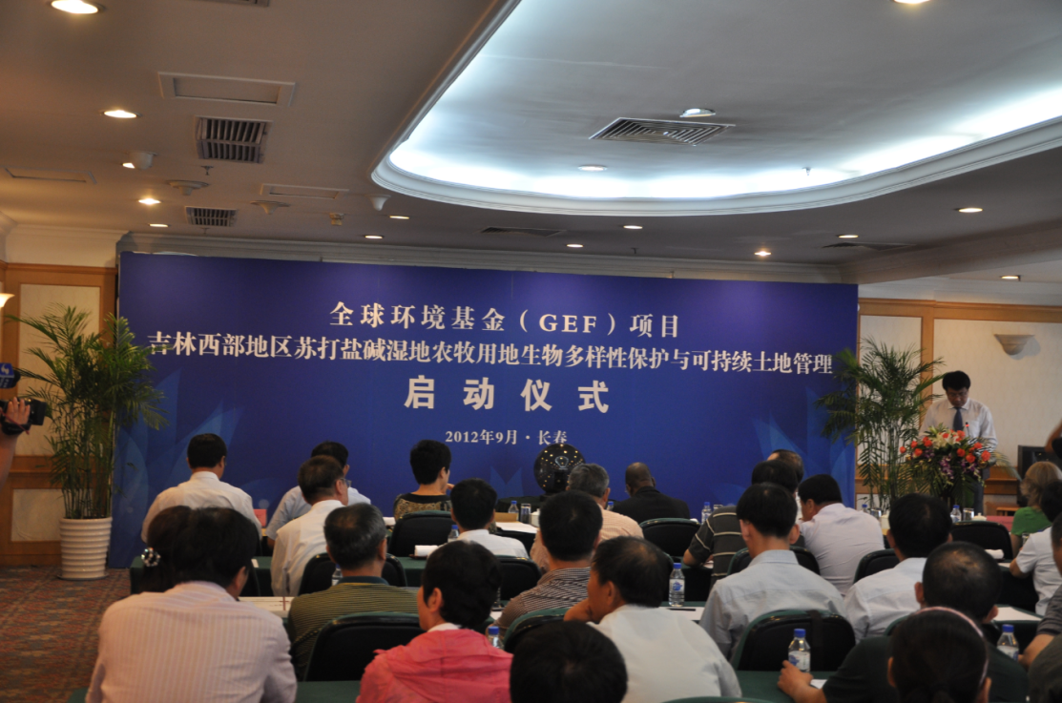
2012年9月，吉林省水利厅原副厅长、项目办主任车黎明在启动仪式上讲话
Che Liming, the former deputy director of the Jilin Provincial Water Resources Department, the former director of the PMO spoke at the kick-off meeting on September,2012
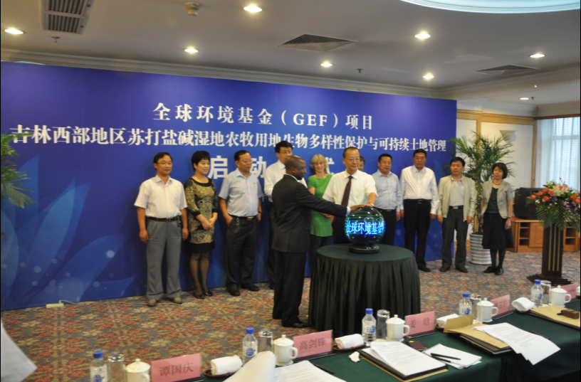
FAO驻华代表Misika与吉林省政府副秘书长李福升共同按下启动球
FAO representative Percy W. Misika and the Deputy Secretary of the government of Jilin province Li Fusheng Press the starting ball together
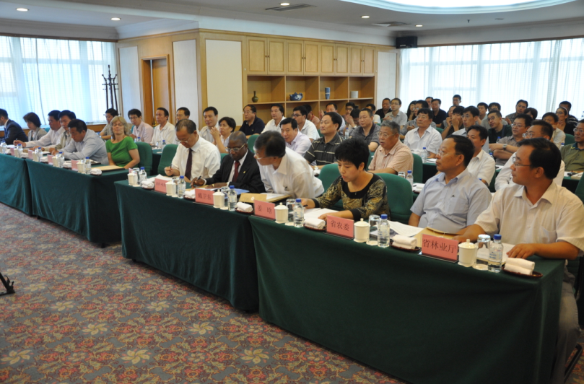
参加启动仪式的各单位领导
Leaders from all departments participate in the kick-off meeting
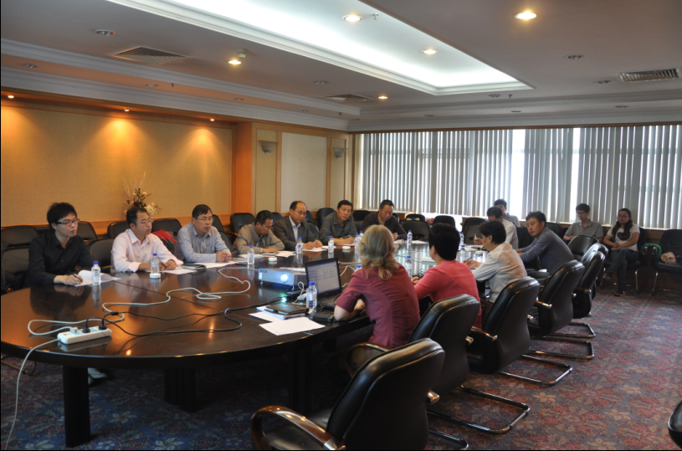
启动仪式后省项目办组织FAO官员与我省专家讨论技术方案
The PMO organize FAO officials to discuss technical proposal with relevant experts after the Kick-meeting
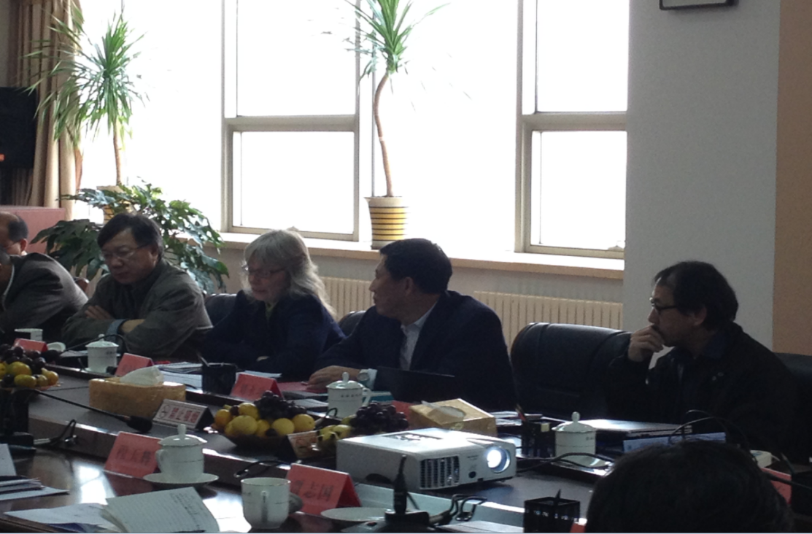
2013年9月28日，水利厅召开利益相关者磋商会。FAO官员左起戴卫东（右四）、Rikke（右三）、刘永功（中方、右二）、Yuji（右一） 参加座谈讨论
The stakeholder consultation meeting has been hold at the Department of Water Resources in 28th, Sep., 2013. The FAO officials who attended the meeting were Dai Weidong (4th from right), Rikke (3rd from right), Liu Yonggong (Chinese, 2nd from right) and Yuji (1st from right)
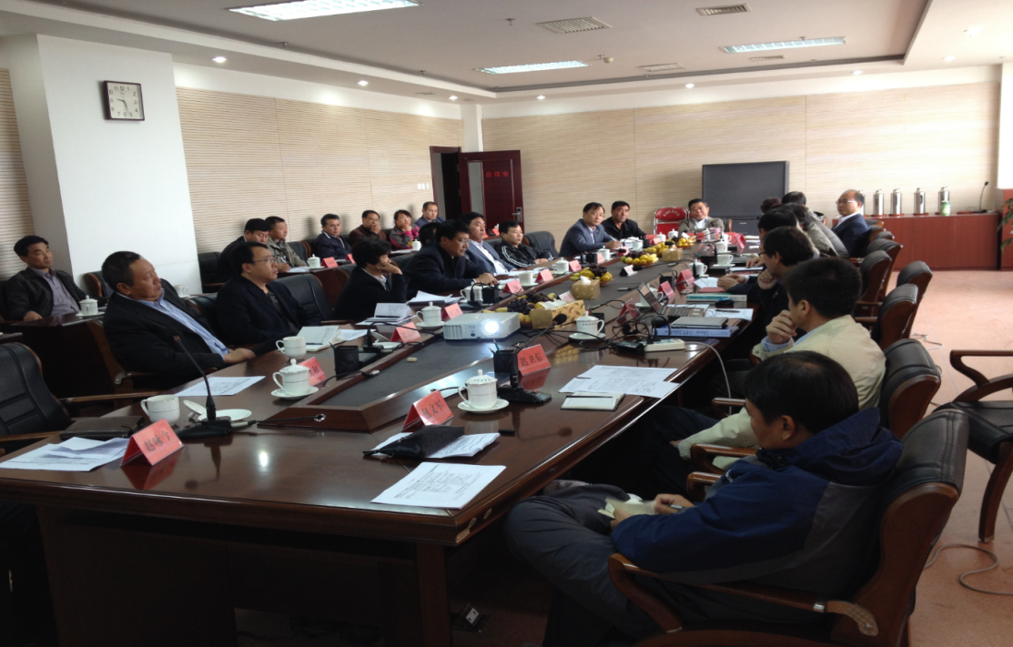
项目办召开吉林省利益相关者磋商研讨会
The PMO held a consultation workshop for stakeholders of Jilin Province
吉林省项目办历经两年完成项目实施文件的编写，项目文件于2015年6月获GEF理事会批准实施，项目执行期为四年。
The PMO of Jilin Province have completed compiling of document of project implementation for two years, and the document has been obtained approval and implemented by GEF council in June, 2015. The project duration is four years.
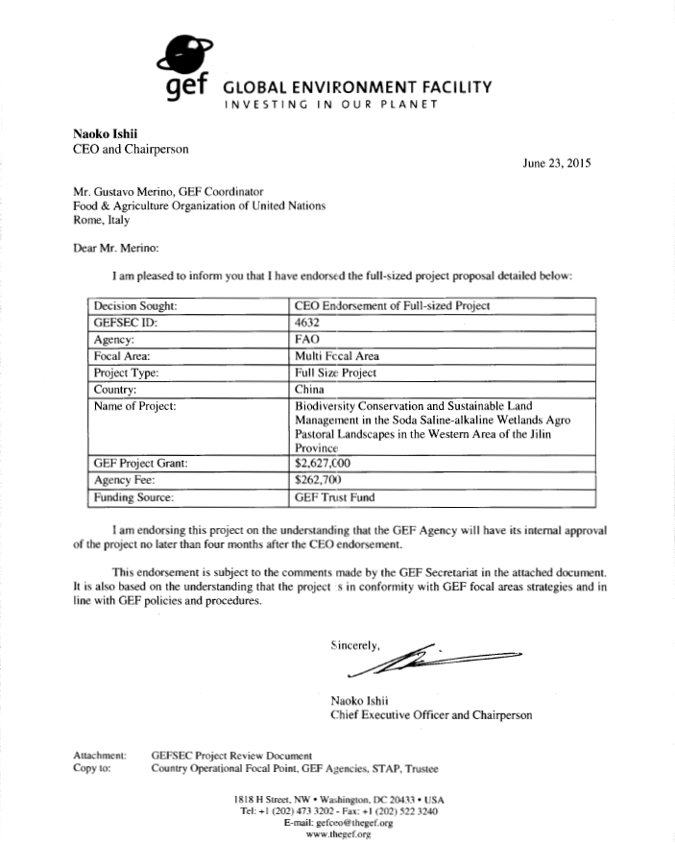
2016年11月，财政部与FAO 签署项目框架协议。
The ministry of finance signed a framework agreement on project with FAO in Nov., 2016.
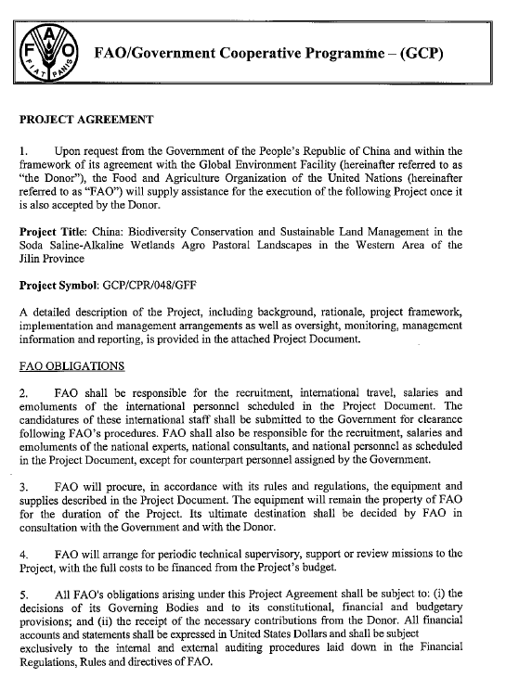
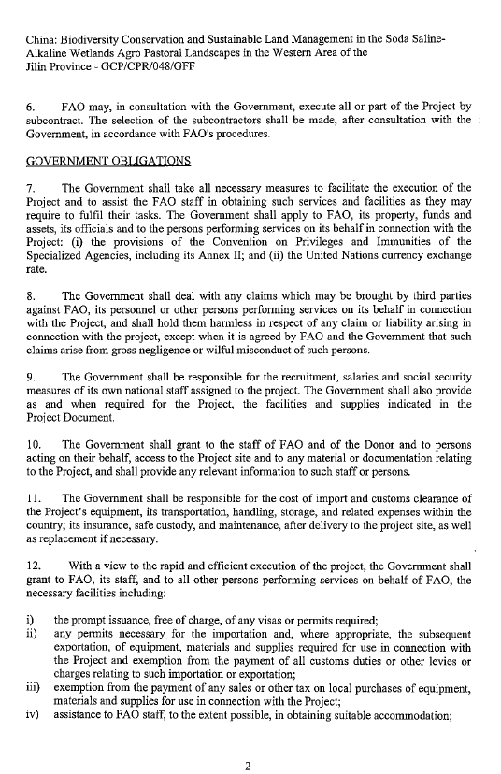
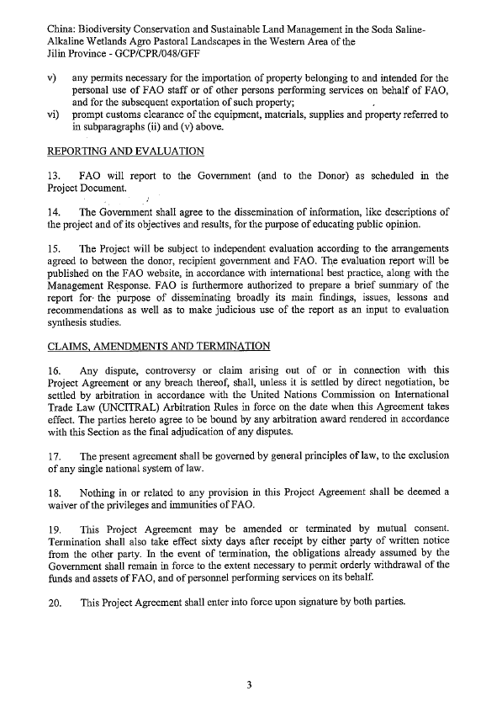
二、吉林西部地区基本情况Basic information in the west area of Jilin
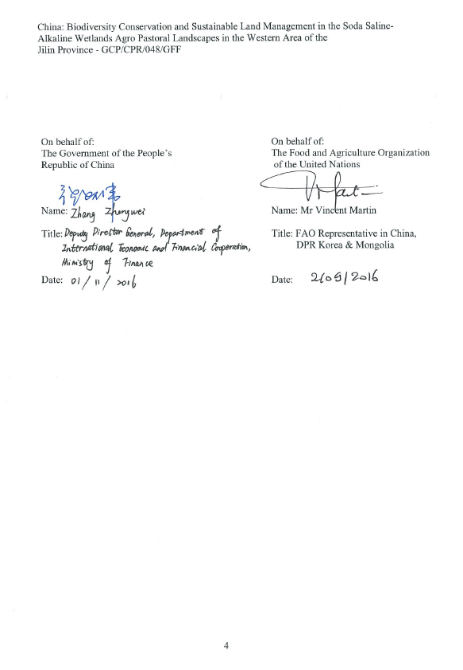

2.1自然情况Natural condition
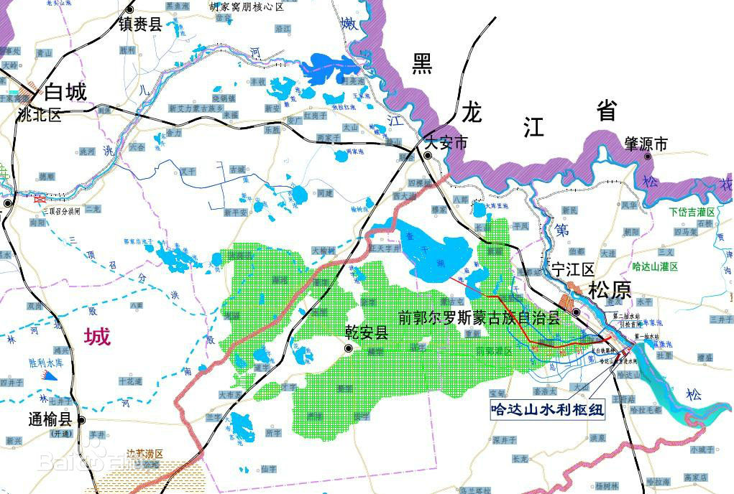
吉林西部地区现辖2个地级市（松原和白城）、11个县，土地面积51,801.5km2，总人口494万人，是吉林省经济相对落后的地区。
The western area of Jilin province, a poorer region in Jilin Province with land acreage of 51,801.5 km2 and a population of 4.94 million, govern two prefectural-level cities (Songyuan and Baicheng) and 11 counties.
吉林西部地区具有苏打盐碱地的特征，广袤的温带湿地和肥沃的草原常常遭遇松嫩平原季节性的洪水作用。这些湿地为当地与全球提供了重要的生态系统服务功能，为各类的水禽类、淡水鱼类与湿地哺乳动物提供了栖息地，也为返西伯利亚和中国南方的迁徙水鸟提供休栖、捕食的场所。其中许多水禽特别是鹤类均为国际自然保护联盟所列的濒危物种。同时，这些湿地中也包括中国最高产的草原。另外还分布有数以千计的小池塘、湖泊和沼泽地，这些湖泊和沼泽为畜牧业及淡水的存储做出贡献。同时池塘和湖泊也支持着当地传统淡水渔业。而且，这些湿地作为缓冲区控制着下游的洪水。
The western part of Jilin Province is characterized by soda saline-alkaline soils. The extensive temperate wetlands and rich grasslands suffered seasonal flooding from the Songnen Plain. These wetlands provide important ecosystem services to local and global, and also provide habitat to a variety of waterfowls, freshwater fish and wetlands mammals, as well as important resting and feeding areas for migratory water birds fly to Siberia and the southern part of China. Many of these water birds, especially the cranes are endangered species listed on the IUCN red-list. Meanwhile, thousands of the one of highest productivity grassland include in these wetland. In addition, thousands of small ponds, lake and swampland distribute in the area, and make contributions to animal husbandry and storage of fresh water, as well as support of local traditional freshwater fishery. These wetlands also serve as a buffer to control of downstream flood.
西部地区位于松嫩平原的西南部，属于半干旱温带大陆性季风气候带，其平均气温4.4℃(温度从1月的-18.1℃变化到7月的23.4℃)，流经该地区的主要河流有洮儿河、霍林河、松花江以及嫩江。近50年来，西部地区平均气温升高了1.9°C，年降水量（约400mm/a）远低于年蒸发量(1030mm/a)，地区来水取决于松嫩平原北部、西部的山区和高原补给，并且易受温度变化及脆弱的水盐浓度平衡系统的影响。由于全球气候变化与湿地退化导致该区域气候变化，湿地、池塘、湖泊干涸（1930-2000年，减少了21%，其中包括20世纪70年代查干湖面积锐减），许多水禽濒临灭绝，牧草地消失（大安县牧草地自1954年至2004年减少21%），土地沙化与盐碱化（大安县自1954年至2004年盐渍化土地增加28%），造成大量碳排放并使碳储存减少（近50年内估计有42%有机碳损失），使该地区成为世界三大苏打盐碱地区之一。吉林省西部的生态环境恶化问题制约了地区经济的可持续发展。
The western Jilin is located in the Southwest part of the Songnen Plain and is in the semi-arid temperate continental monsoon climate belt, with an average temperature of 4.4C (varying from 23.4C in July to -18.1C in January), main rivers crossing the area include Tao’er River, Huolin River, Songhuajiang River and the Nenjiang River. The last 50 years the average temperature has increased by 1.9°C.The annual precipitation (around 400 mm/year) is much lower than the annual evaporation (1030 mm/year). This makes the area dependent on water inflow from the mountain areas and higher plateaus north and west of the Songnen Plain and vulnerable to changes in temperatures and the fragile water and salt concentration balance. The wetlands in this area have in been influenced by land use and climate changes affecting the ecosystem services they provide. The impacts include drying up of swamps, ponds and lakes (reduced by 21% from 1930 to 2000 ,including the significant reduction of the Chagan Lake in the 70-ties), many water birds are on the verge of extinction ,disappearance of grassland (reduced by 21% from 1954-2004 Da’an county), and decertification and salinization processes (increase in salinized land by 28% from 1954-2004 Da’an County) leading to significant emissions of green house gasses and reduction in carbon stocks (an estimated 42% loss in organic carbon in the last 50 years), these makes the region into one of the world's three major soda areas. The deterioration of the ecological environment in the west of Jilin Province restricts the sustainable development of regional economy. The deterioration of the ecological environment in the west of Jilin Province restricts the sustainable development of regional economy.

2.2骨干工程Key project
为了抑制土地退化进程，保护天然草地，国家和省政府于1999年发布了实行环境保护和恢复的政策，比如圈闭退化草场、禁止放牧等。
In order to prevent the process of land degradation and protect the natural grassland, the State and the provincial government issued a policy of environmental protection and recovery in 1999, such as trap the degraded grassland, closure against grazing.
引嫩入白工程。工程总投资为18.6亿元，其中引水和灌区骨干工程投资16.4亿元，灌区田间工程投资2.2亿元，以满足城市经济发展和人民生活需求。
Project: Lead the water of Nenjiang to Baicheng City. Total project investment is 1.86 billion RMB, including diversion and irrigated area key project investment 1.64 billion, irrigated area farmland project investment 0.22billion, used for satisfied the development of city economic and people’s living needs.
哈达山水利枢纽工程。该工程投资约58亿元，用于改善松原灌区内的退化农田和恢复湿地和草原，对提高松原市的防洪标准，削减松花江干流洪峰有着积极作用。也是为解决吉林西部地区干旱缺水、第二松花江洪水及作为北水南调工程的水源工程等而建。
Hadashan key water-control project. The project has invested about 5.8billion, used for improve the degraded farmland in the irrigated area, as well as the recovery of wetland and grassland. Have a positive effect on enhance the flood control standard of Songyuan City and cut down the flood peak of main streams of Songhua River. It is also build for the drought and hydropenia area in western Jilin, the flood of the second Songhua River and the water source project of north-to-south water diversion project.
松原灌区工程。该工程是正在实施的吉林省增产百亿斤商品粮能力建设的重点工程，是已开工建设的哈达山水利枢纽工程的主要配套工程。灌区的田间工程也是正在实施的吉林省西部土地整理重大工程的重要组成部分。
Songyuan irrigated area project. The project is a key project of Jilin province which is in implementation that used to build the abilities of increased billions marketable grain; it is the main auxiliary project of the Hadashan key water-control project which is already in construction. The farmland project in the irrigated area is also an important part of the land consolidation major project in the west Jilin.
河湖连通工程。2015年2月，水利部会同吉林省人民政府联合批复了吉林西部河湖连通工程规划，工程等别为Ⅱ等工程，规划新建、改扩建渠道工程1000公里，新建泵站水源工程9座，辅以桥、涵、闸等建筑物近500处，工程总投资56亿元。
River and lake connected project. February, 2015, Ministry of Water Resources conferred with the People’s Government of Jilin Province concerted to replied “River and lake connected project plan in western Jilin”, the project level is Ⅱ, planning to build, reorganization and expansion channels 1000kilometres, and 9 pump stations and water source projects, accompanied by bridges, culverts, floodgates nearly 500, total project investment is 5.6 billion.

三、项目内容Project content
该项目是吉林省申报的首个全球环境基金项目，属于大型生态系统服务功能保护项目，项目的全球环境目标：在盐碱化的农牧用地示范和推广包括湿地恢复和生物多样性保护的可持续土地和水资源管理模型。
The project is the first GEF project which is applied by Jilin province, belongs to large-scale zoology system service function protect project, the global environment objective of the project is: set an example and promoted the management model including SLWM of wetland restoration and biodiversity protection in the salinization agro-pastoral landscapes.
为了对土地和水资源实现可持续管理，项目设计时需要有一个可持续应用的灌溉系统，同时要对现有的农业耕作模式进行调整，以便将水土管理和生物多样性保护服务结合起来。吉林西部地区由于哈达山水利枢纽工程而形成的湿地成为国内外公认的理想试验点。
In order to realize the sustainable management of land and water resources, there should be a sustainable application irrigated system when the project is designed, at the same time it should be adjusted on the existing agricultural cultivation mode, in order to make the water and soil management and biodiversity protection services fell together. The wetland in western Jilin which is formed by Hadashan key water-control project becomes a recognized ideal test pilot both in China and aboard.
项目以哈达山水利枢纽和松原灌区工程为依托，项目区范围22万公顷。松原地区水资源短缺，湿地退化严重，再加上过度开采地下水和不可持续的土地和水资源管理使得该区域生态系统接近崩溃。近些年的人类活动严重加剧了这种状况，生态系统面临不可逆转的恶化，且依靠自身很难得以修复。该区域的查干湖国家级自然保护区是候鸟短暂停留地，具有重要的生态系统服务功能。查干湖生态系统的稳定性很大程度上取决于周围农牧用地的耕作模式，特别是新水田退水形成的湿地。
The project based on Hadashan key water-control project and Songyuan irrigated area project, the scope of the project area 220000 hectares. Songyuan area is short of water, wetland was degraded severely, and over-exploitation of underground water and un-containable land and water resources management make the ecological system close to collapse. Recent years, the human activities serious intensified this type of condition; the ecological system is face with irreversible deterioration, and hard to repaired depend on itself. The Chagan Lake national natural reserve of the area is the whistle stop place of the migratory bird, be provided with important ecosystem service function. The stability of Chagan Lake ecosystem greatly depends on farming mode of agro-pastoral landscapes in the surrounding area, especially wetlands formed by water recession of new paddy field.

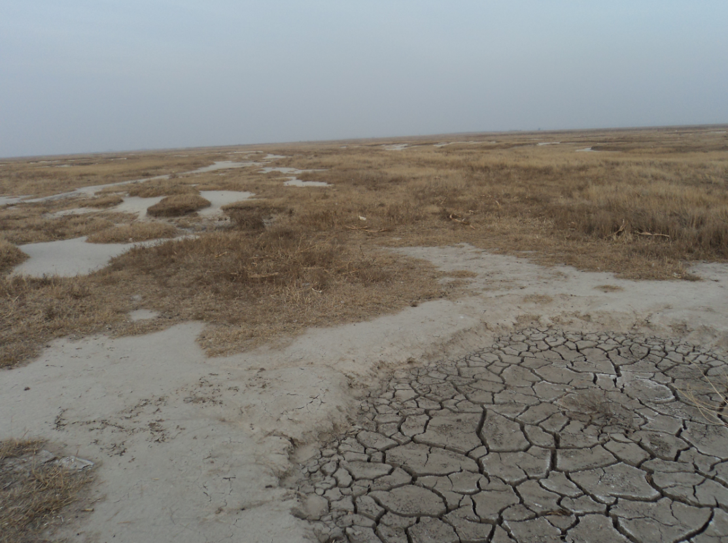
吉林西部地区盐碱地现状
The present situation of saline-alkali soil in the western area of Jilin Province
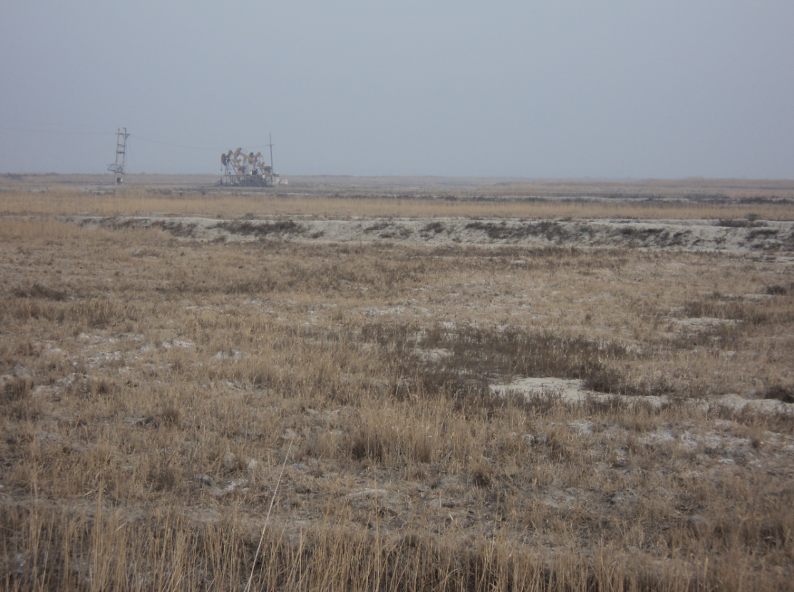
待开发水田
Paddy field to be developed
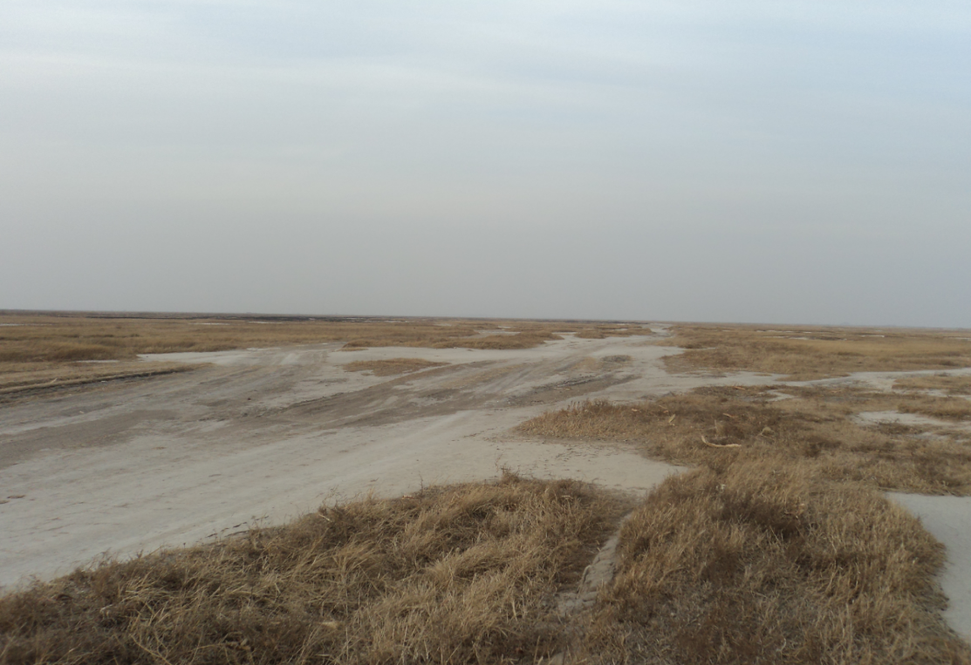
退化的草原
Degraded grassland
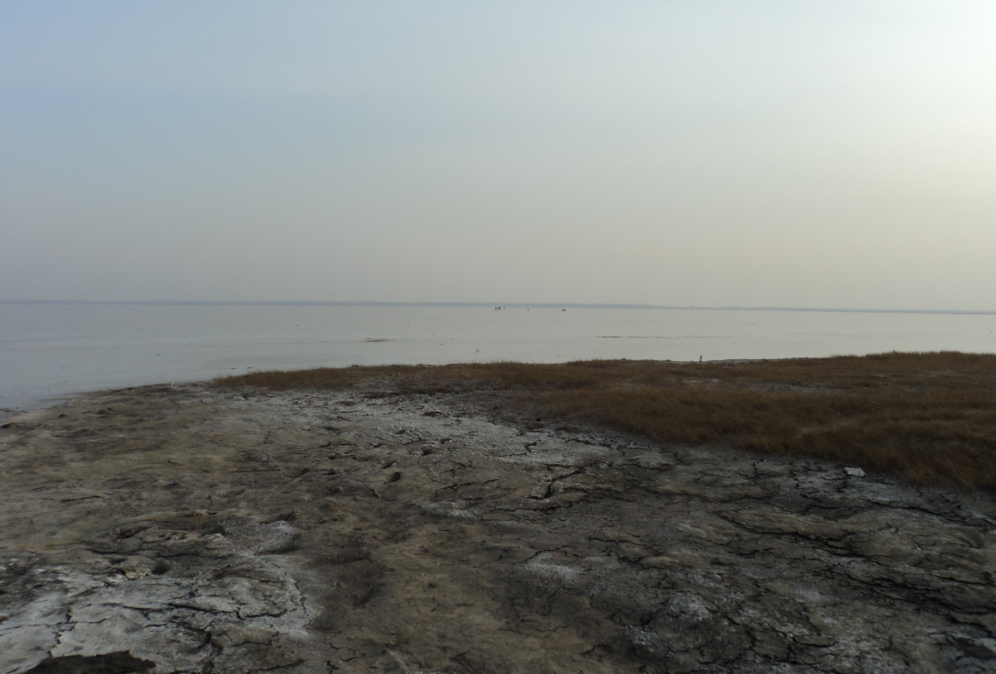
有字泡退水承泄区
Drainage receiver of the Youzipao
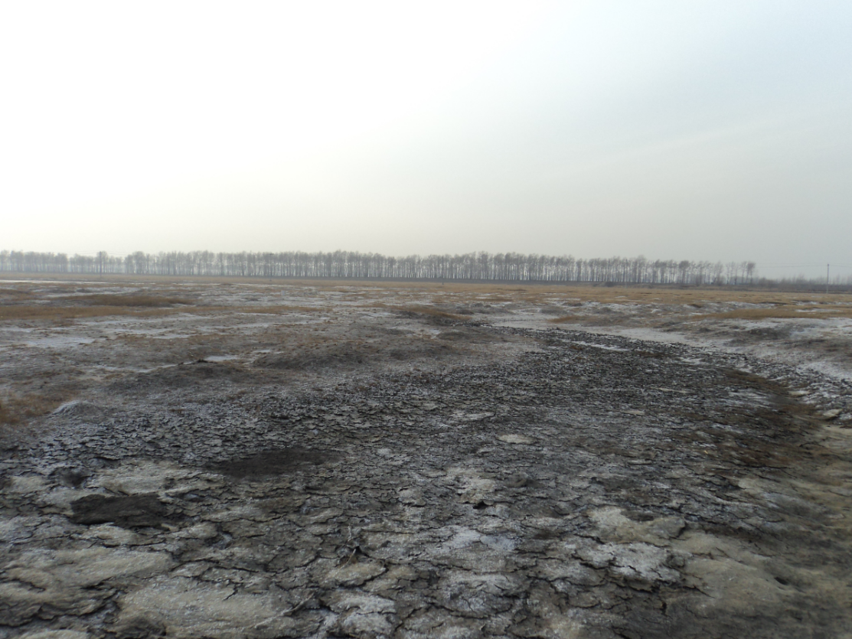
有字泡周边退化的土地
Degraded land around the Youzipao
项目针对吉林省西部地区土壤盐渍化、荒漠化及沙化等导致的环境问题，拟采用一种环境友好型的调水方法，使人们更清晰的认识到这种创新方法对生态系统的影响以及在促进生物多样性保护和土地管理上具有的巨大潜力，从而实现环境效益最大化，项目可分为四个部分：
The project aimed at environmental problem results from soil salinization and desertification in the western part of Jilin Province. We plan to adopt a water diversion method of environment friendly type, so as to make people more clear understanding the kind of innovation method affect on ecosystem, and immense potential to promotion of biodiversity protection and land management. Thus realize maximizing the benefits. The project can be divided into four parts:

3.1为在农牧用地中采用可持续水土管理模型完善政策、法规和监管框架，包括能力建设

Adopt sustainable water and land management model in the farming land to improve polices laws and regulatory framework, including capacity building
项目将在现有法律法规基础上，针对各有关部门的政策空白，建立综合农牧用地管理方法，为在农业生产中实现可持续土地和水资源管理、恢复退化土地和长期的生物多样性保护相结合提供有利的政策保障。此外，项目将为当地的技术人员和农民提供培训，推广相关技术并提高其环保意识，使可持续水土管理可以长期执行。
Based on existing laws and regulations, the project will aim at policy vacuum from all related departments, and establish management method of integrated farming land. It will provide beneficial policy guarantee to realize combination of sustainable land and water resource management, recover degraded land and long-term biodiversity protection in agricultural production.

3.2在查干湖周边设计并试点实施可持续水土管理和保护性农业

Design and experimental implementation of sustainable water and land management and conservation agriculture around Chagan Lake
该项目将制定和实施一套与可持续土地和水资源管理相一致的可替换性农业耕作方法，解决项目区因水资源短缺导致的土地退化，包括节水灌溉，减少化肥农药的过度使用和保护性农业等，将农业耕作方法的改进与生态系统恢复紧密结合起来，以增加植被覆盖率，避免湿地被污染。同时，项目还将为当地制定综合的土地和水资源管理计划，作为土地和水资源管理部门的使用工具，对农业、草原和生物多样性保护统筹管理，提高相关部门监督、管理和预防能力。
The project will formulate and implement a series of replaceable method of agricultural cultivation to consist with sustainable land and water resource management, which will solve land degradation resulted from shortage of water resources in the project area, including water-saving irrigation, reduce overuse of chemical fertilizer and pesticide, and conservation agricultural. We closely combine improvement of agricultural cultivation method with recovery of ecosystem so as to increase vegetation coverage and avoid pollution of wetlands. Meanwhile, the plan of comprehensive land and water resource management will be formulated as serviceable tool for land water resource management department in the project for the purpose of overall management for agricultural, grassland and biodiversity protection, and improve supervision, management and prevention ability for relevant department.

3.3恢复湿地和草原，从而改善查干湖周边区域的生物多样性保护机制

Recovery of wetland and grassland to improve mechanism of biodiversity protection around Chagan Lake.
通过利用现有的枢纽工程和灌溉设施恢复试点区域的湿地与草原。吉林西部土壤含盐量较高，恢复湿地的水和径流进入查干湖可能会导致水盐量升得太高，造成生态破坏。因此，项目设计并建立的综合水质水量监测系统，以监测盐度变化、污染物的水平、水量和生物多样性的变化，并作为一个早期预警系统。通过调水系统严格控制流入湿地的水量和时间，利用监测系统控制盐分含量及污染物水平，两者结合起来将可以有效控制湿地的恢复，并确保湿地恢复的长期可持续性。
Wetland and grassland from pilot area will be recovered by using existing pivotal project and irrigation facility. The soil salinity is high in the western part of Jilin Province, so water and runoff from recovered wetland will enter into Chagan Lake, which will cause soil salinity rise too fast and ecological damage. Therefore, the comprehensive quality and quantity of water monitoring system will be designed and established by project to monitor variation of salinity, level of pollutant, water yield and biodiversity change.

3.4监测和评估项目活动，推广项目成果，提高公众环保意识

Monitor and evaluate project activities, popularize project outcome and improve public environmental awareness.
通过对项目开展活动的监测和评估，确保项目按设计实施；同时协调不同部门参与进来，将项目取得的先进经验进行推广传播，确保项目效益的最大化。
According to implement monitor and evaluation of activities, the project will be designed and implemented as plan. At the same time, the different department will be participate, and advanced experience obtained from the project will be popularized and propagated to insure maximization of project benefit.

四、预期成果和环境效益Expected results and environmental benefits
全球环境基金项目的实施不仅为带来了优惠资金，更重要的是带来了国际先进理念，加强了我们履行相关国际公约的能力，引进了一批新技术和先进的管理机制，增强了公众的可持续发展意识。
The implement of the GEF project not only bring us favorable funds, but bring more importance international advanced idea, enhanced our ability to carry out the correlation international convention， introduced a batch of new technique and advanced management mechanism, and enhanced the sustainable development awareness of the public.

4.1预期成果Expected results
项目的发展目标是通过建立一个具有生态弹性的农牧用地系统，从而使吉林西部社区农民可以从农业系统中（农作物种植、畜牧业和渔业）获得长期的可持续的收益。
预期取得的成果有：
（一）可持续土地和水资源管理模型（SLWM）。
（二）综合的土地和水资源管理计划（ILWMP）。
（三）为在更大范围内容实施和推广SLWM模型完善政策、法规和监管框架。
（四）对政府管理人员、技术推广人员和社区群众进行培训，提高其管理水平、技术水平和环保意识。
The development goal of project is that community farmers from the western part of Jilin Province can obtain long-term sustainable benefit from agricultural system (crop planting, animal husbandry and fishery) by establish a agro-pastoral landscapes with ecological elasticity.
The expected results include:
(i)Sustainable land and water resource management model.
(ii)Integrated land and water resource management plan.
(iii)Implement and popularize SLWM model within a large area to improve policy, laws and regulatory framework.
(iv)Training of management staff from government, technological promotion staff and community masses to improve management level, technological level and environmental awareness.

4.2环境效益Environmental benefits
通过改善吉林西部苏打盐碱地生态环境，可以有效遏制土地退化，保护项目区生物多样性，增加可持续水土管理范围。对环境的改善和直接的效益如下:
（一）将增加83,500公顷（松原灌区荒改水）盐碱地的植被覆盖率，提高其可持续生产能力，降低受气候变化影响的脆弱性，阻止土地退化与沙化的进程；
（二）利用可持续水土管理模型的综合生产用地将达到22万公顷（松原灌区面积）；
（三）恢复与保护16,988公顷湿地，使之成为综合淡水渔业、灌溉农作物与草原的一部分，为濒危候鸟休息与觅食提供重要的栖息地；
(四)水鸟和濒危候鸟的湿地栖息地将得到保护，数量有所增加。
该项目的实施可以促进区域可持续发展，提高全球环境质量，改善项目区生态环境，对促进吉林省经济社会的可持续发展具有重要意义，符合我国建设生态文明的战略部署。
It will efficient prevent land degradation and protect biodiversity in the project area, and increase scope of sustainable water and land management by improving ecotope of soda saline-alkaline wetlands. Improve environment and direct benefit as follows:
(i)Increase vegetation coverage of 83,500 ha.(wasteland change into paddy field in Songyuan irrigation) Saline-alkali soil, improve sustainable production capacity, reduce vulnerability affected by climate change, prevent land degradation.
(ii)Make use of comprehensive production land from sustainable water and land management model is reach to 0.22 million ha. (Songyuan irrigation acreage).
(iii)Recover and protect 16,988 ha. wetlands . Comprehensive fishery, irrigation crop and grassland have been part of it, and provide habitat to rest and foraging food for endangered bird.
(iv)Wetland habitat for water bird and endangered species were protected, and quality was increasing.
The implementation of project will improve regional sustainable development, advance global environment quality, and improve ecotope of project area, which will be of great significance to improve sustainable development of economic society of Jilin Province, and accord with strategic deployment of ecological civilization of our country.

